**DAB Statistical Analysis of Customer Data**

Based on the statistical analysis of the data, you can conclude the following key points:

1. There is a positive correlation between Spending Score and Satisfaction Level.

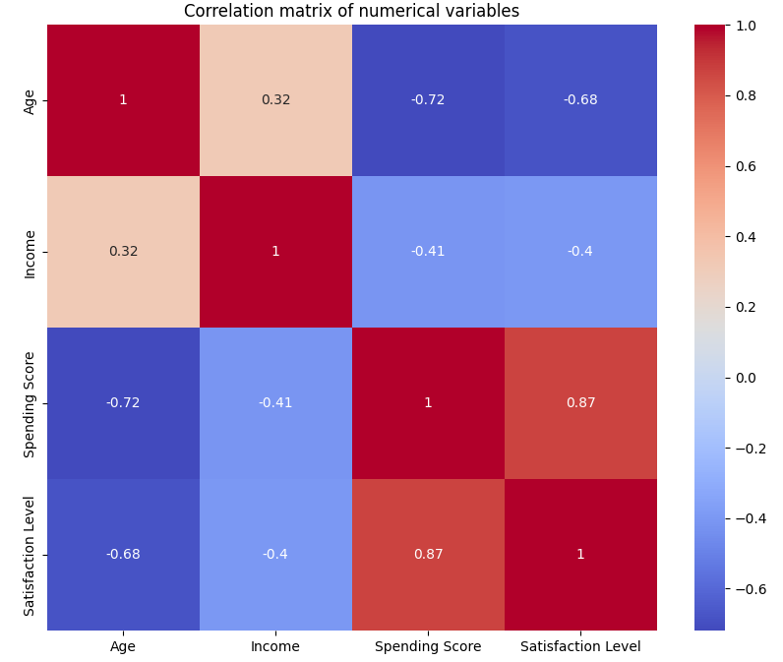

1. T-Statistic: 13.633632374041511

P-Value: 1.9308315031620856e-36

We reject the null hypothesis. There is sufficient evidence to say that the mean Satisfaction Level is not equal to 7.

**This means that the average Satisfaction Level in the data differs from 7.**

1. 95% confidence interval for the mean Satisfaction Level: (np.float64(7.4860184250006405), np.float64(7.649219670237455))

**The range of the mean with 95% confidence is between 7.486 and 7.649.**

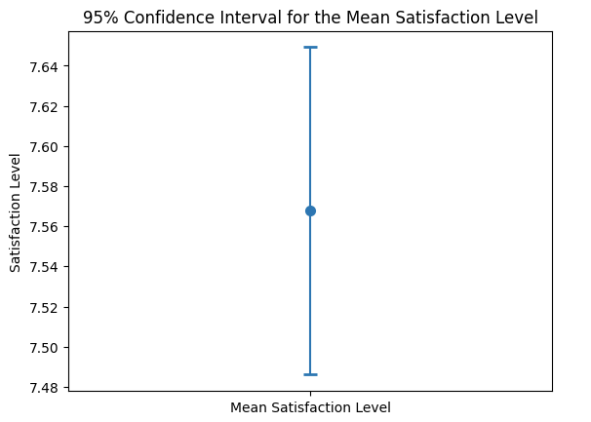

1. Females generally have a higher Satisfaction Level than Males.

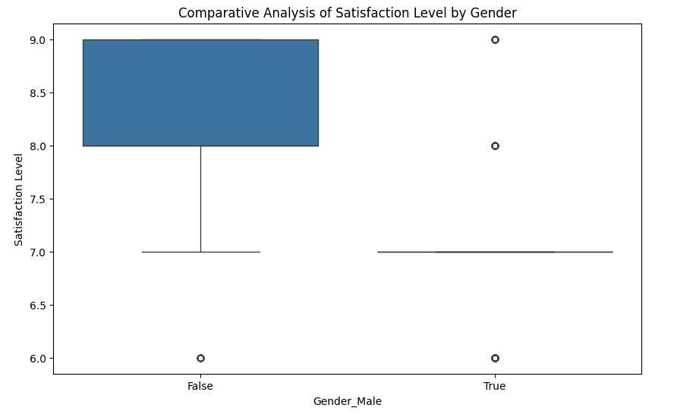

1. Customers with Associate’s degrees have the highest Satisfaction Level while those with PhDs have a lower Satisfaction Level.

